CASE STUDY OF CLICKCLIKAT STUDIOS

**A Final report for the BDM capstone Project** Submitted by

Name: SAYALEE S. DAMLE

Roll number: 21F1002588



IITM Online BS Degree Program,

Indian Institute of Technology, Madras, Chennai Tamil Nadu, India, 600036

**Declaration Statement**

I am working on a Project Title: “CASE STUDY OF CLICKCLIKAT STUDIOS”. I extend my appreciation to CLICKCLIKAT STUDIOS, for providing the necessary resources that enabled me to conduct my project.

I hereby assert that the data presented and assessed in this project report is genuine and precise to the utmost extent of my knowledge and capabilities. The data has been gathered through primary sources and carefully analyzed to assure its reliability.

Additionally, I affirm that all procedures employed for the purpose of data collection and analysis have been duly explained in this report. The outcomes and inferences derived from the data are an accurate depiction of the findings acquired through thorough analytical procedures.

I am dedicated to adhering to the information of academic honesty and integrity, and I am receptive to any additional examination or validation of the data contained in this project report.

I understand that the execution of this project is intended for individual completion and is not to be undertaken collectively. I thus affirm that I am not engaged in any form of collaboration with other individuals, and that all the work undertaken has been solely conducted by me. In the event that plagiarism is detected in the report at any stage of the project's completion, I am fully aware and prepared to accept disciplinary measures imposed by the relevant authority.

I agree that all the recommendations are business-specific and limited to this project exclusively, and cannot be utilized for any other purpose with an IIT Madras tag. I understand that IIT Madras does not endorse this.

Signature of Candidate: 

Name: SAYALEE S. DAMLE

Date: 15-03-2024

TABLE OF CONTENTS

EXECUTIVE SUMMARY 4

DETAILED EXPLANATION OF ANALYSIS PROCESS/METHOD 4

RESULTS AND FINDINGS 6

INTERPRETATION OF RESULTS AND RECOMMENDATION 18

**FINAL REPORT FOR THE BDM CAPSTONE PROJECT**

### **EXECUTIVE SUMMARY**

This Capstone Project in Business Data Management aims to address common challenges encountered by businesses through the application of analytical methods. Specifically, the project will utilize business analytics techniques to propose solutions tailored to the needs of Clickclikat Studios, a media-centric company.

ClickClikat Studios is a small media business which engages in event photography and videography. This project's primary goal is to discover the issues with data maintenance and the company's social media presence. The number of events that the business obtains as a result of social media is shown by the analysis of the data that was taken from such platforms. Data of events and the cost is also used for analysis.

With a growing market, new tools and technology, advanced editing techniques, the photography industry is expanding. There are multiple aspects to this line of work.

Understanding the elements is essential for comprehending the operations of these enterprises. The information provided by ClickClikat Studios will undergo analysis utilizing Python and Google Sheets. A correlation study will be conducted based on event quantities and social media engagement. Python will be utilized to find correlation factors and facilitate visualization. The data will be stored in Google Sheets. Primary data sourced from the enterprise will be used for analysis. Diverse data analysis methodologies will be applied across various timeframes. Various factors will be employed to identify patterns and evaluate correlation.

### **DETAILED EXPLANATION OF ANALYSIS PROCESS/METHOD**

The owner, Prasanna Kulkarni, has provided information on clients, quotations, and invoices going back to March 2019.

This information is stored in Wave App, a small business owner's one-stop resource for money management.

Instagram data was gathered using Meta services. This information dates from the time the Instagram handle was created.

Instagram handle: <https://instagram.com/clickclikat?igshid=MzRlODBiNWFlZA==>

Data can be accessed using this link:

<https://drive.google.com/drive/folders/1GV8H4u6WhgjTleW6Bgz_DiQ9b8puCINQ?usp=sharing>

Steps of Analysis:

1. Data Collection: The analysis process began with the collection of relevant data, including conversion rates from estimates to invoices and total likes received per year on social media platforms. This data was sourced from internal business records and social media analytics tools.
2. Data Preparation: The collected data was organized and prepared for analysis. This involved cleaning the data to remove any inconsistencies or errors, as well as structuring it into a format suitable for analysis.
3. Descriptive Analysis: Descriptive statistics, such as mean conversion rates and total likes per year, were calculated to provide an initial overview of the data. This step helped identify key trends and patterns that formed the basis for further analysis.
4. Visualization: Data visualization techniques, such as bar charts and pie charts, were employed to visually represent the data and identify trends. Visualization aided in understanding complex relationships and patterns within the data.
5. Statistical Analysis: Statistical methods, such as correlation analysis, were used to quantify relationships between variables. This step helped determine the strength and direction of relationships, such as the correlation between conversion rates and total likes per year.
6. Interpretation of Results: The findings from the analysis were interpreted to derive meaningful insights and conclusions. This involved examining trends, patterns, and correlations within the data to understand the factors driving business performance and audience engagement.
7. Recommendations: Based on the insights gained from the analysis, actionable recommendations were formulated to improve business strategies and outcomes. Recommendations aimed to address identified areas for improvement and capitalize on opportunities for growth and optimization.

Outcome should be based on these points:

1. The business needs to analyze how social media benefits the business.
2. How to maintain or increase the number of events that the business gets.
3. Find correlation between social media data and system data.
4. The business needs an easier way to organize their data and store it.
5. Enterprise resource planning (ERP) is not user- or cost-friendly, thus a small-business oriented ERP software is required.

### 

### **RESULTS AND FINDINGS**

**The Wave App stores the following information about estimates:**

Data is entered according to the ‘estimate number’. This data is sorted based on the date column.

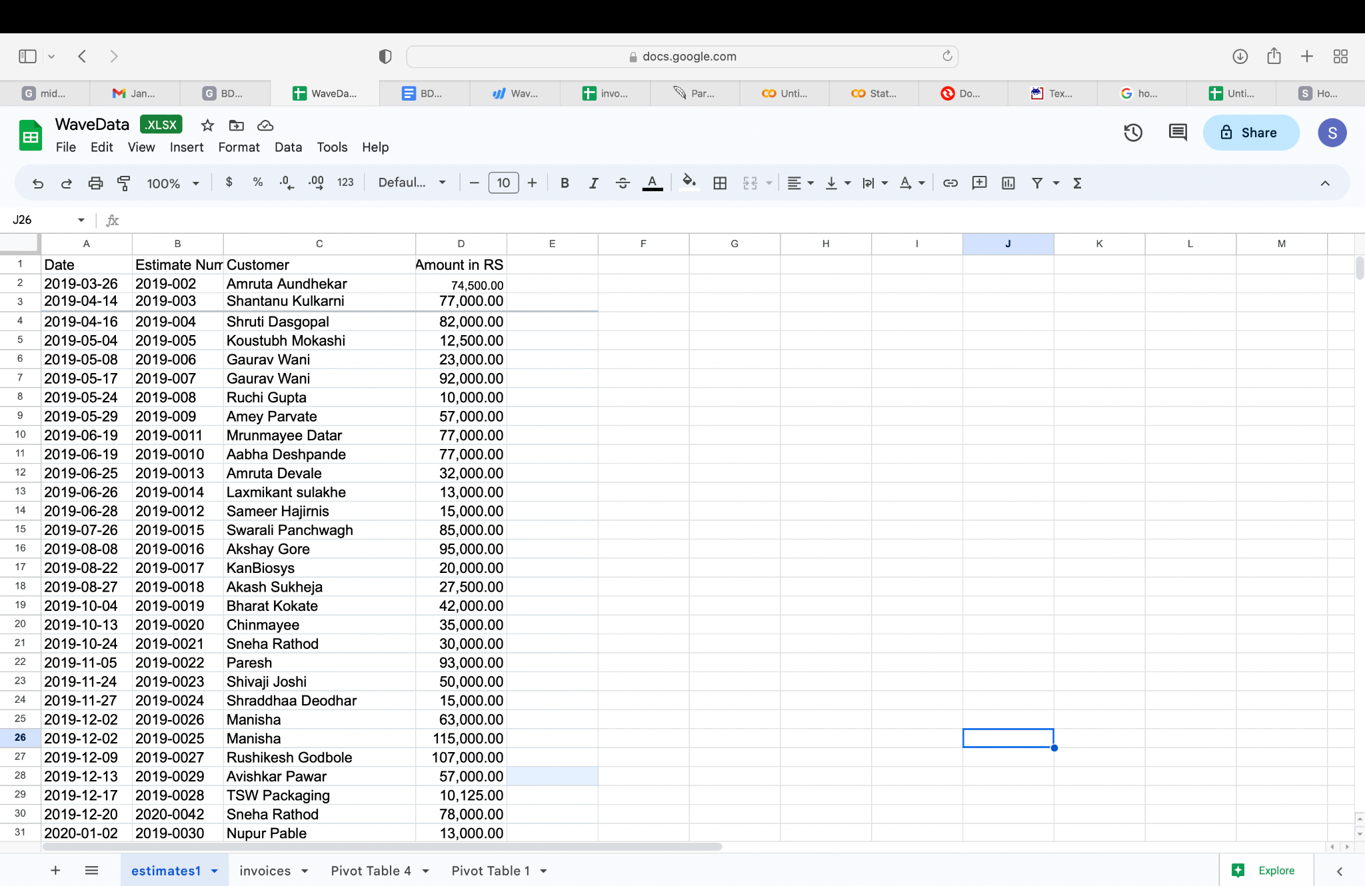

Figure 1

**Invoice Data is stored as follows:**

This Data is manually entered according to the ‘invoice number’. Invoice number is set according to the date of event.

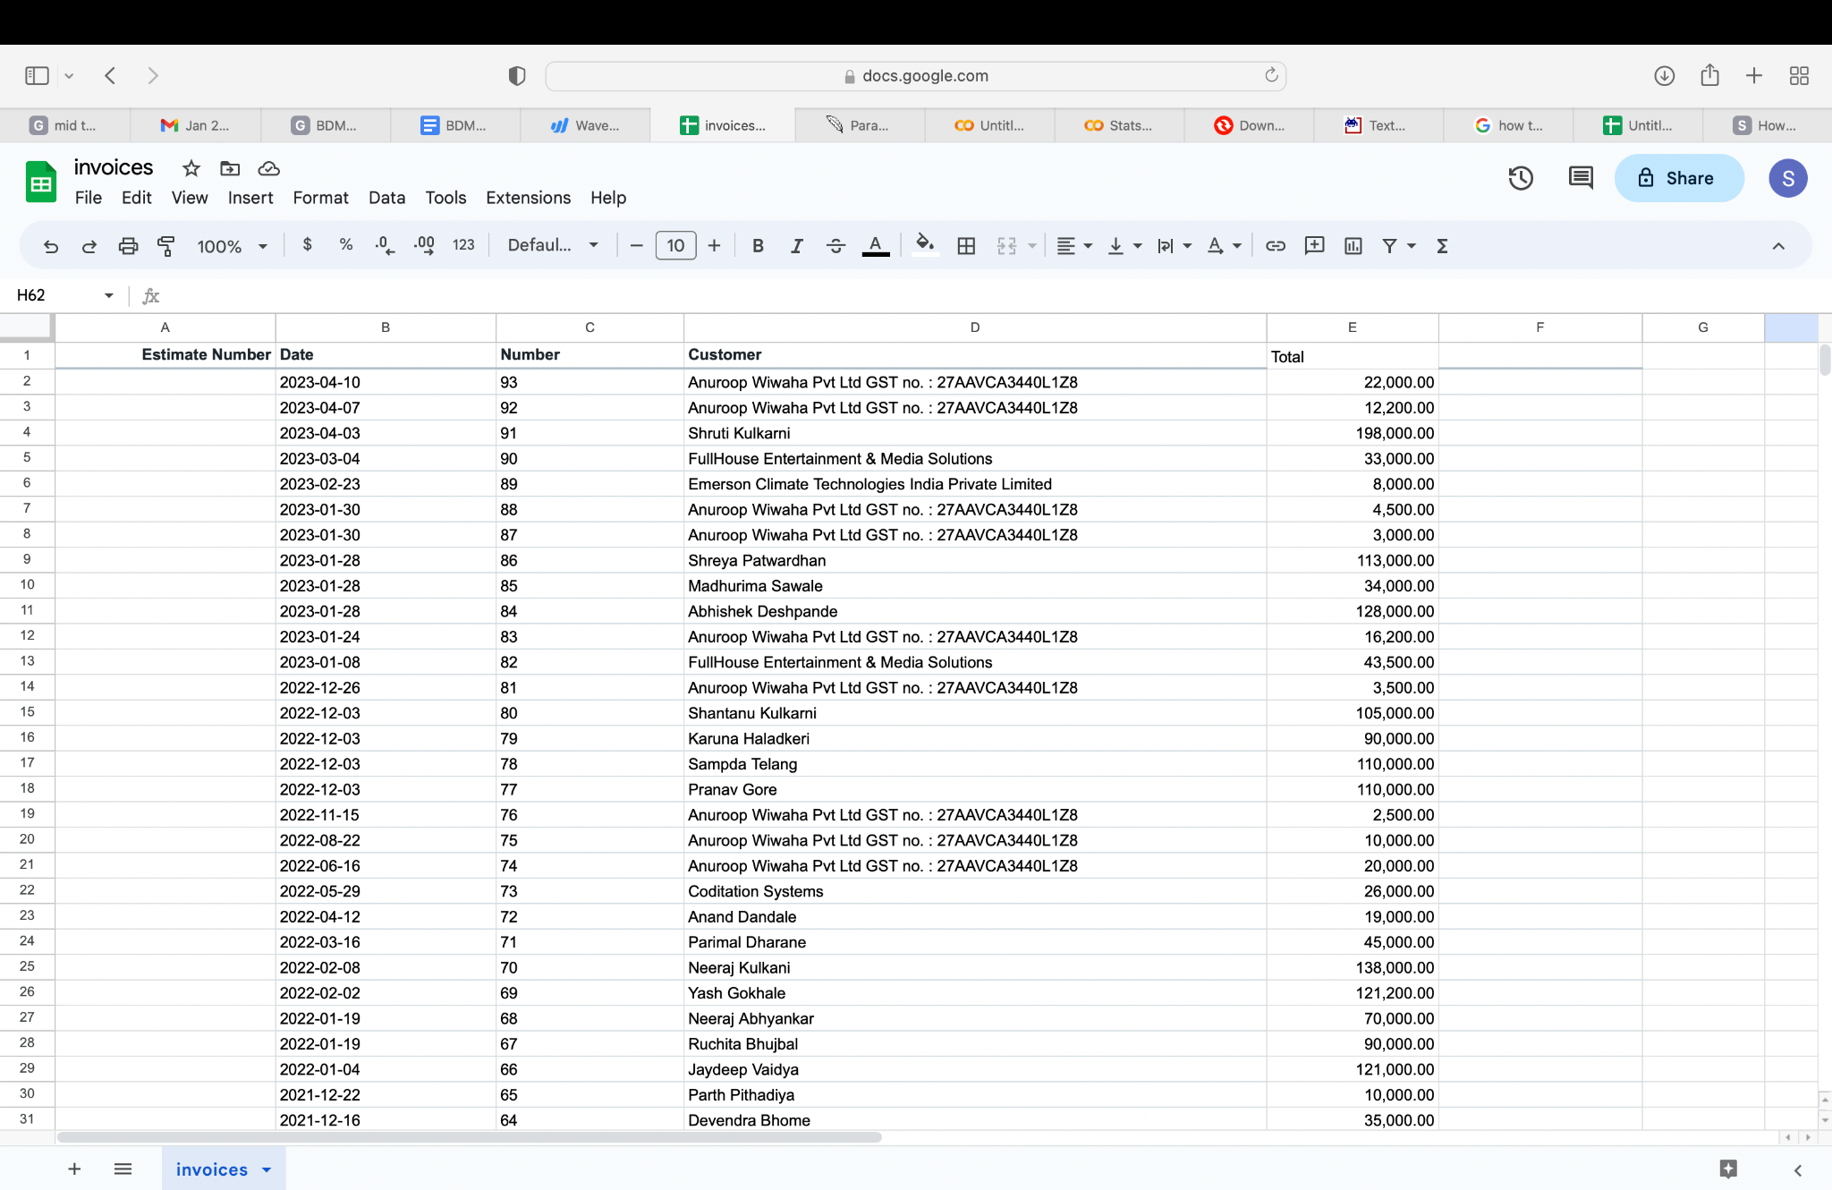

Figure 2

Invoice Data is to be linked to the Estimates Data by entering the estimate number for each invoice.

This helps to correlate between invoices and estimates.

**Instagram Data:**

Data was scanned thoroughly and the number of likes were taken. The data collected will undergo thorough analysis to identify trends, patterns, and correlations that may exist among different aspects of the business. This analysis will involve the application of statistical methods, data visualization techniques, and exploratory data analysis to gain a comprehensive understanding of the dataset.

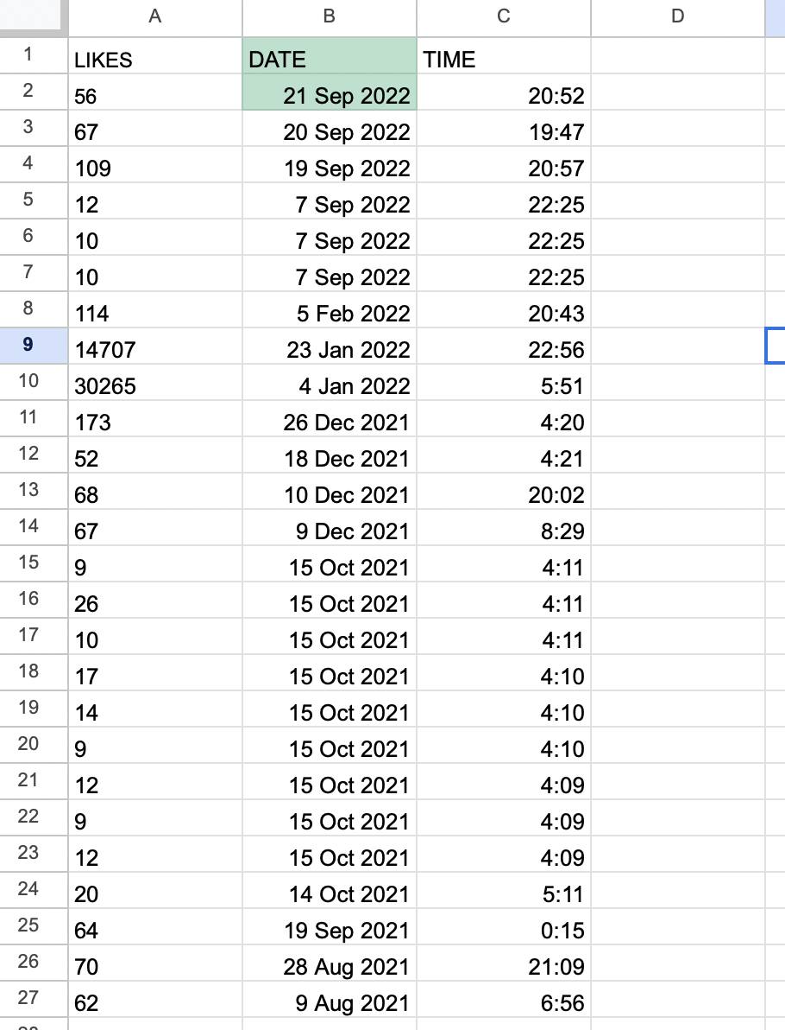

Figure 3

**Analysis of Data collected from Wave**

1. The breakdown of the data is done yearwise. Data for the number of estimates and invoices per year and per month is taken.

Estimates for 2019:

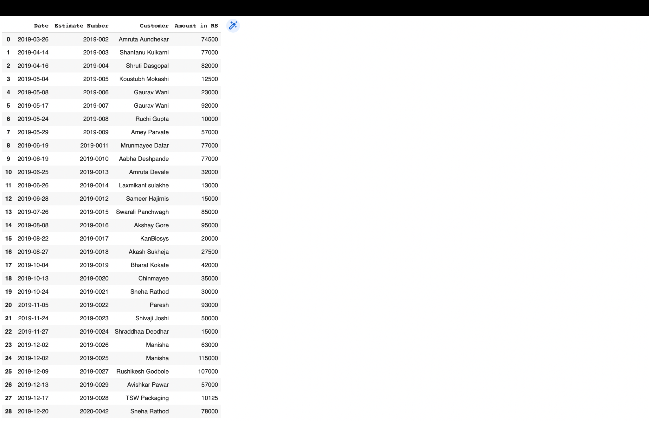

Figure 4

Invoices for 2019:

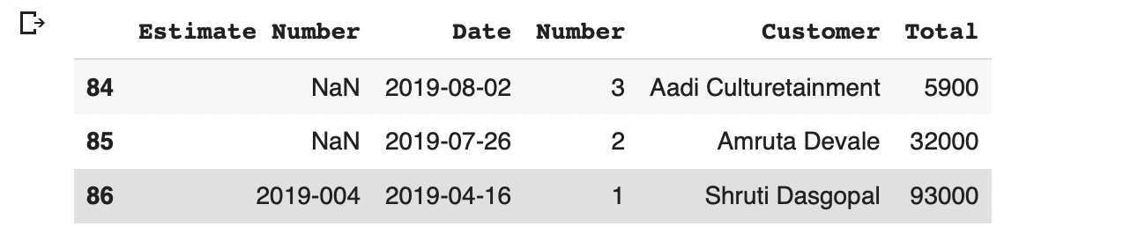

Figure 5

Estimates and invoices for the years- 2020, 2021, 2022, 2023 are extracted similarly.

Analyzing invoices and estimates on a monthly basis for each year allows for a detailed comparison through bar charts, offering insights into the business's operational dynamics and client interactions. One notable observation is the consistent trend wherein the number of estimates sent exceeds the number of invoices generated, indicating a proactive approach to client engagement and business development.

Notably, the months of October, November, and December emerge as the busiest periods consistently across all years under consideration. This trend suggests a seasonal pattern wherein demand surges towards the end of the calendar year, possibly influenced by factors such as holiday season promotions, year-end budget allocations.

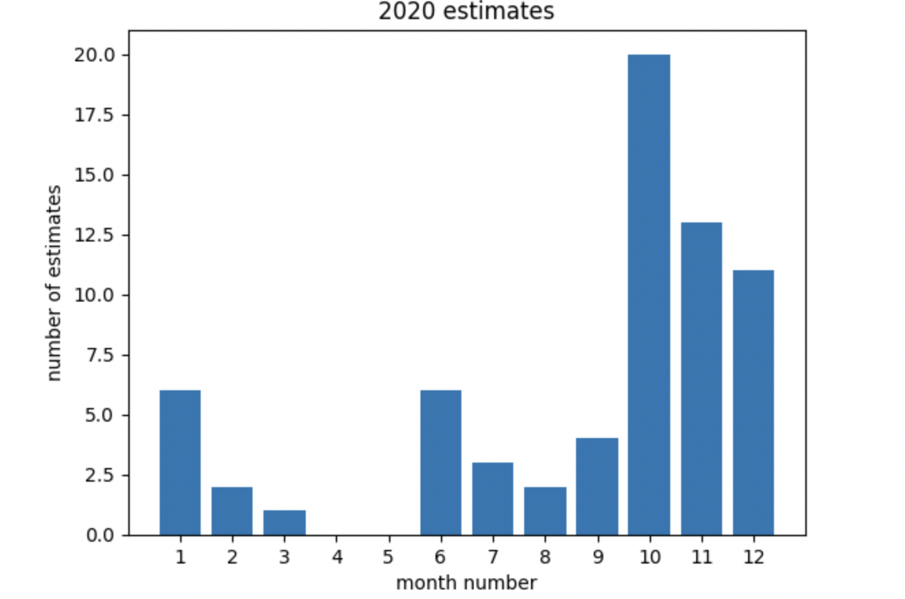

Figure 6

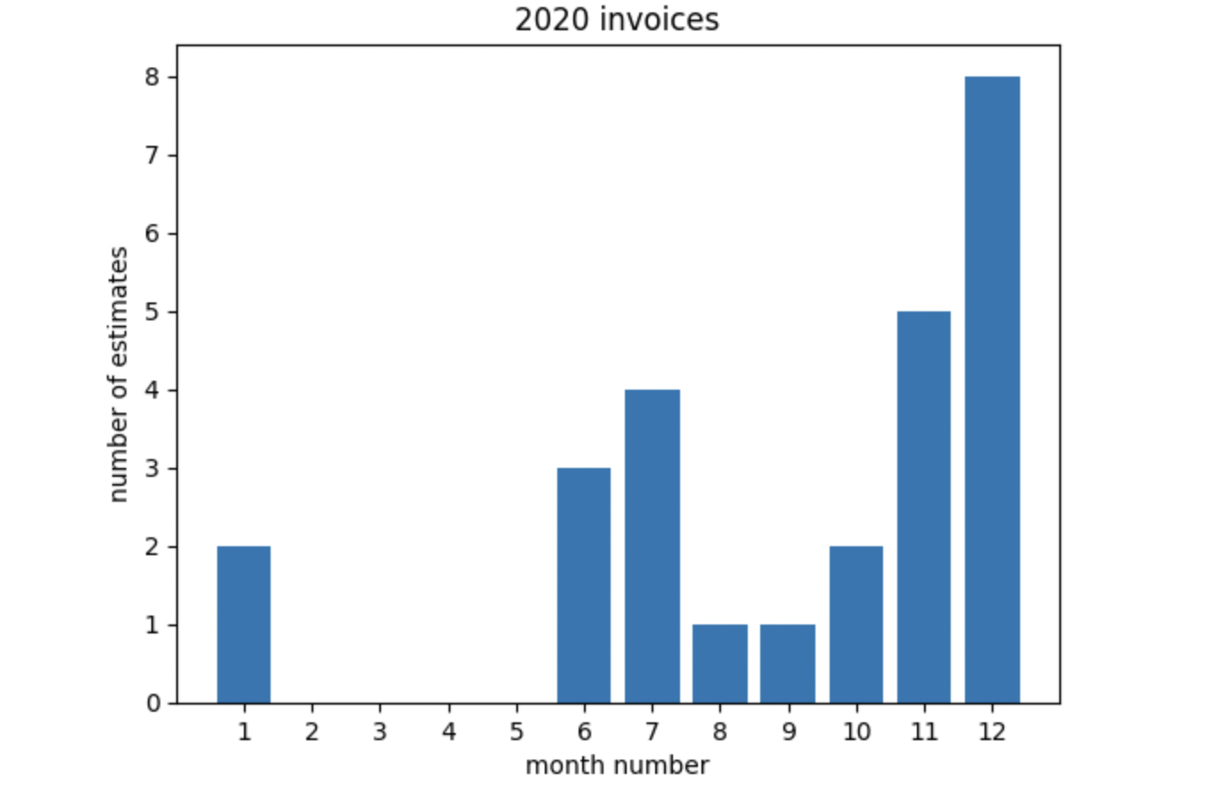

Figure 7

Charts for the years- 2020, 2021, 2022, 2023 are plotted similarly.

Analyzing monthly trends over multiple years facilitates the identification of long-term patterns and cyclical fluctuations in business activity. By understanding the underlying drivers behind these trends, businesses can develop informed strategies to capitalize on peak periods of demand, while also maintaining agility and flexibility to adapt to changing market conditions throughout the year.

1. Yearly Comparison:

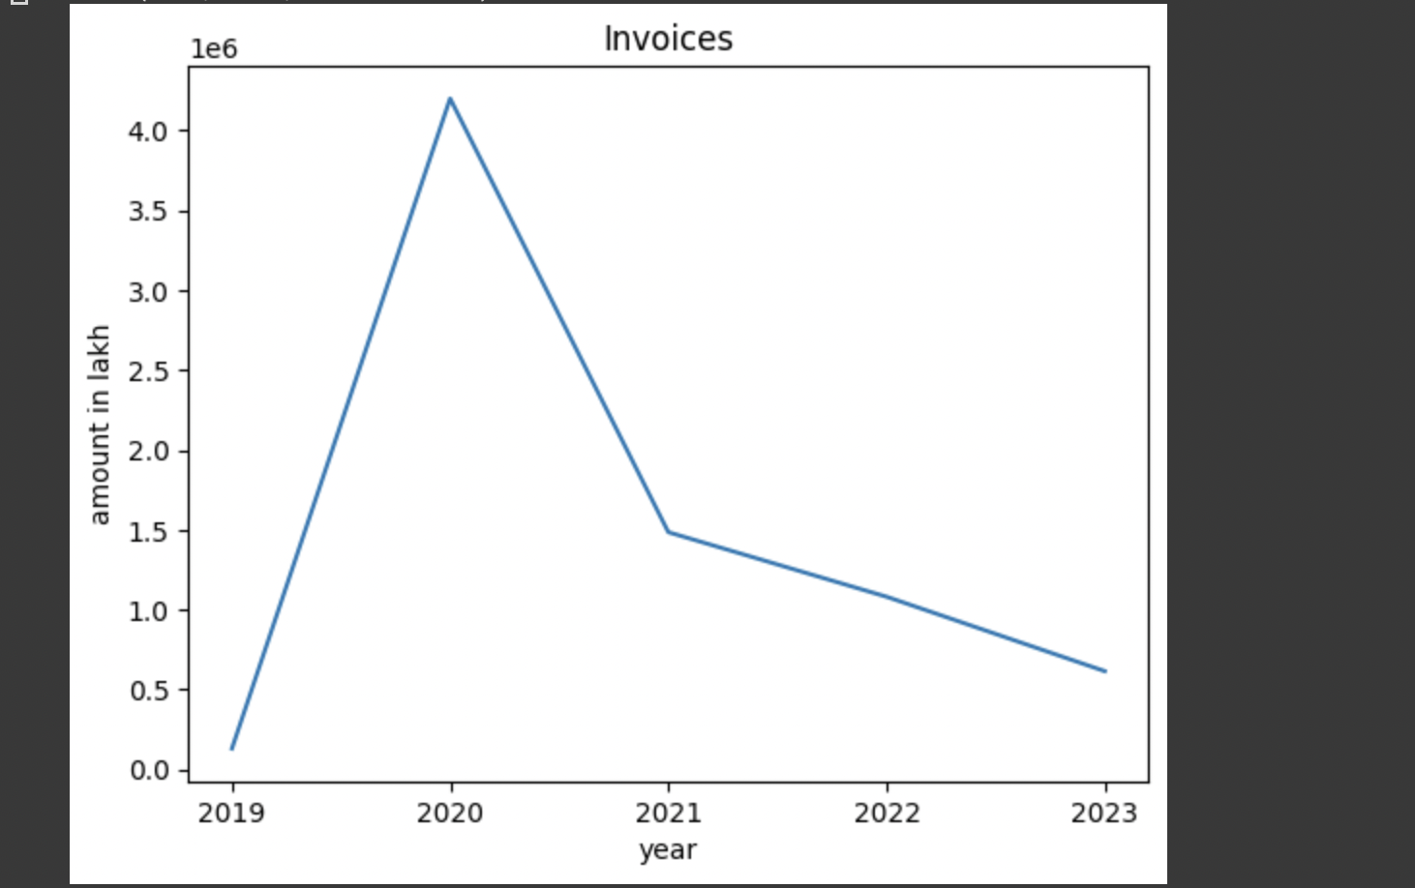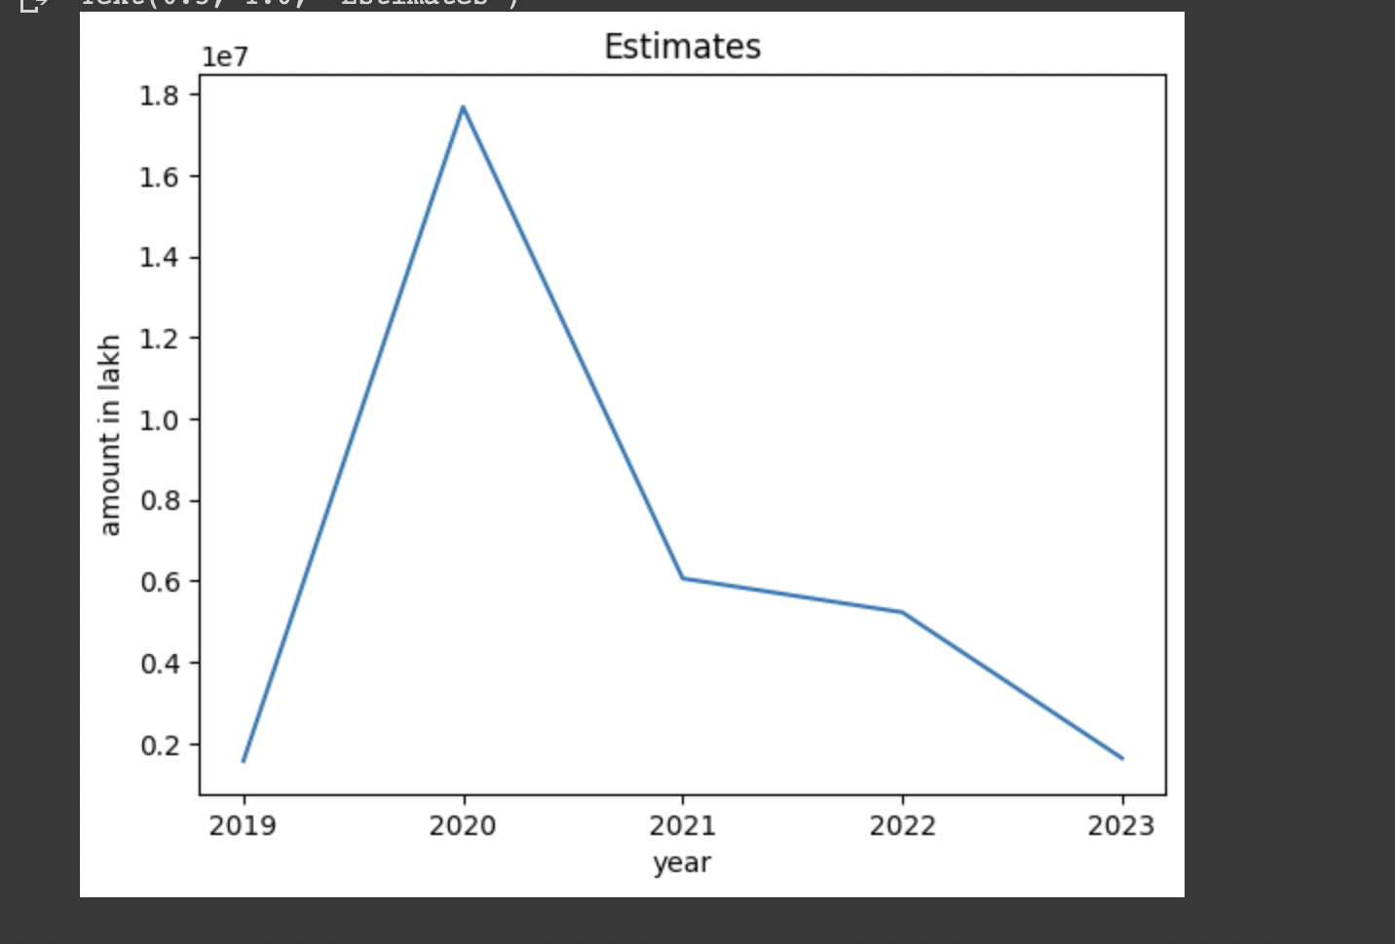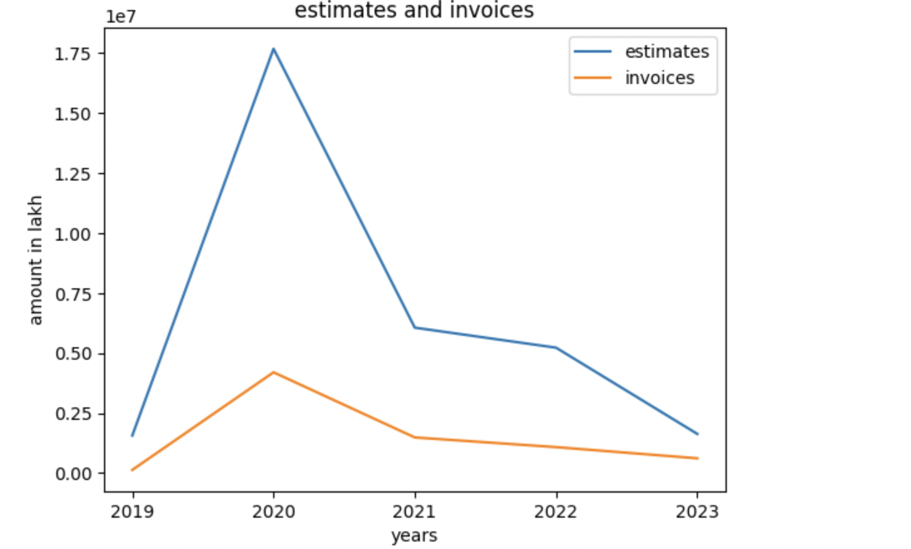

Figure 8 - Chart 3,4,5

The estimates for 2023 appear to be lower due to the availability of data only for the early part of the year. This limited dataset offers insights into the fluctuations in invoices and estimates on an annual basis. Through visual representations such as charts and graphs, we can discern the patterns and trends within the dataset.

Upon closer examination, these visualizations reveal that the business experienced a significant upswing in 2020, characterized by robust growth and profitability. This particular year stands out as a period of notable success, marked by the highest level of profit obtained across all recorded periods.

The observed boom in business during 2020 underscores the effectiveness of strategic initiatives or market conditions prevailing during that time. Analyzing the factors contributing to this exceptional performance can provide valuable insights into the business's strengths, opportunities, and areas for improvement.

Moreover, understanding the contrast between the prosperous year of 2020 and the comparatively lower estimates for 2023 can inform strategic decision-making. By identifying the drivers behind the peak performance in 2020 and assessing the factors influencing the subdued estimates for 2023, businesses can adapt their strategies to capitalize on opportunities and mitigate risks in the evolving market landscape.

1. Calculating the percentage of conversion from estimates to invoices for each year.

It provides valuable insights into the effectiveness of the business's sales process and customer engagement strategies. By comparing the number of invoices generated to the number of estimates sent, businesses can assess their ability to convert leads into actual sales.

Additionally, computing the average estimated and actual sales figures enables businesses to track their sales performance with a single value, offering a concise overview of their revenue generation efforts. This metric serves as a key performance indicator (KPI) for evaluating the business's sales effectiveness and financial health.

Analyzing these metrics over time allows businesses to identify trends and patterns in their conversion rates and sales performance, enabling them to make data-driven decisions to optimize their sales strategies and improve overall business performance.

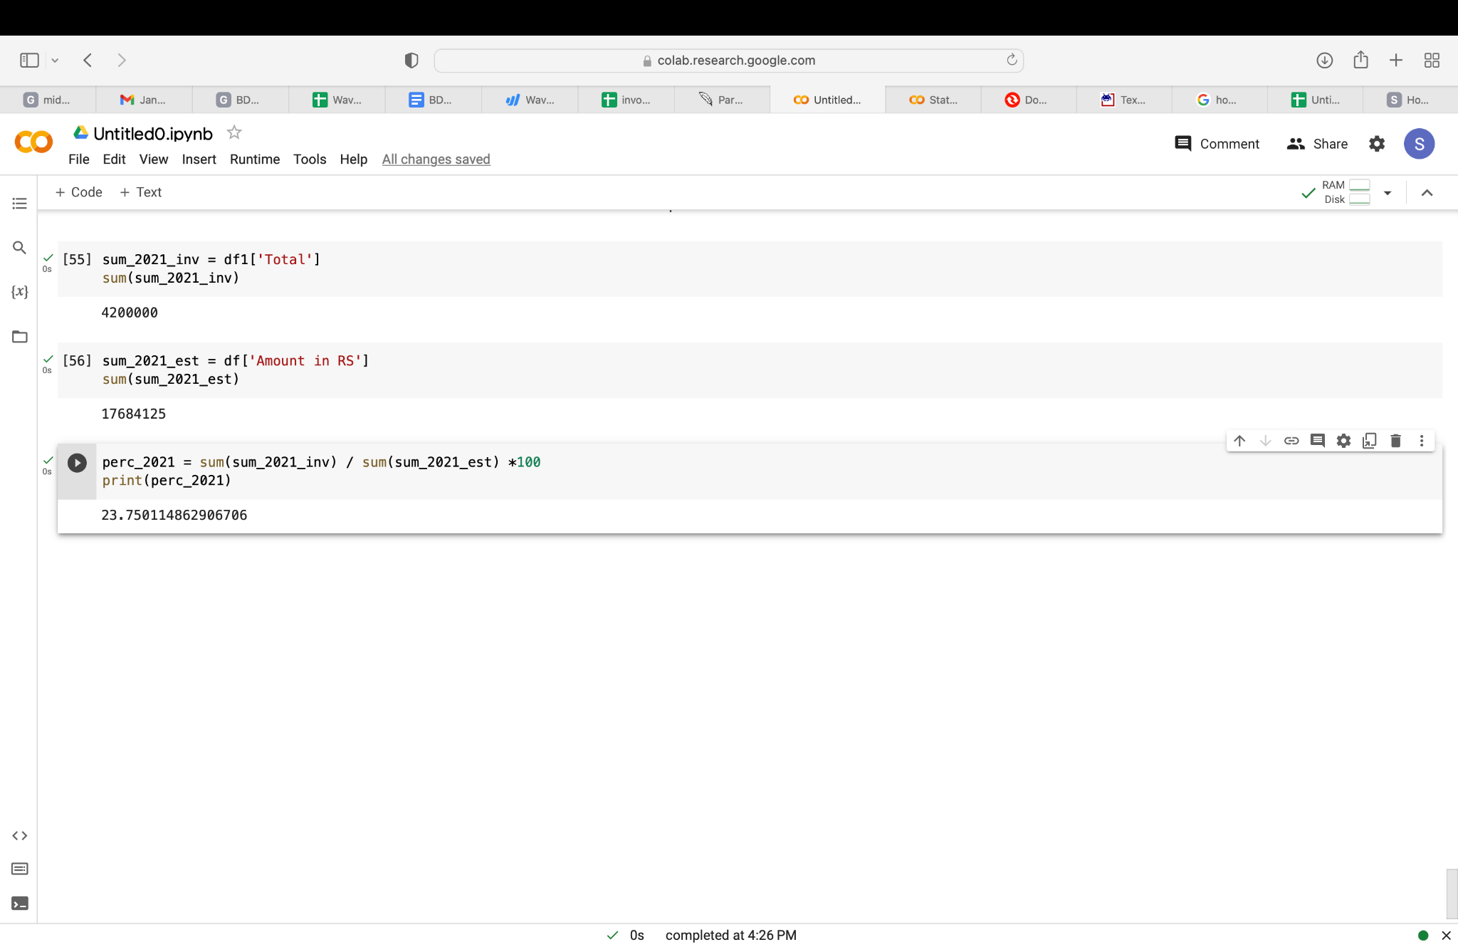

Figure 9

The percentage value for all the years are taken.

Leveraging conversion rates and average sales metrics provides businesses with actionable insights to optimize their sales processes, maximize revenue generation, and achieve long-term success in today's competitive marketplace.

1. Creating a pie chart to represent income per year, specifically focusing on the conversion of estimates to invoices, offers a visual depiction of revenue distribution across the years 2019 to 2023. Each segment of the pie chart corresponds to a specific year, with the size of each segment indicating the proportion of income derived from converted estimates within that year.

By examining this pie chart, stakeholders can easily discern the relative contribution of converted estimates to the total revenue generated each year. A larger segment signifies a higher proportion of estimates successfully converted into invoices, reflecting stronger sales performance and revenue growth. Conversely, a smaller segment suggests a lower conversion rate.

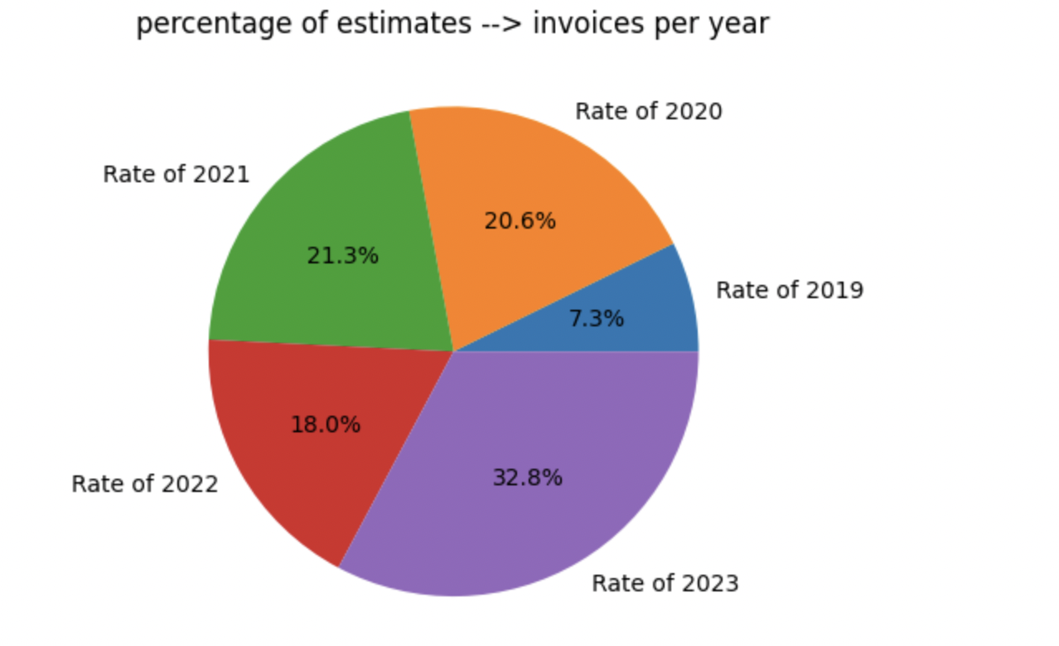

Figure 10

Visualizing income per year through a pie chart enhances communication and comprehension among stakeholders, facilitating data-driven decision-making and strategic planning. By identifying trends, patterns, and areas for improvement, businesses can refine their sales strategies, allocate resources effectively, and drive sustainable revenue growth over the years.

**Analysis of number of likes per post collected from Instagram**

1. Total Likes per year are calculated and a bar chart is drawn for a monthly distribution

By aggregating the likes received on all posts within each year, businesses can assess the effectiveness of their content strategy and audience engagement efforts over time.

Once the total likes per year have been calculated, visualizing the monthly distribution of likes through a bar chart provides a clear and concise representation of engagement patterns throughout the year. Each bar on the chart corresponds to a specific month, with the height of the bar indicating the total number of likes received during that month.

Comparing the monthly distribution of likes across different years allows businesses to identify recurring patterns and assess the effectiveness of their engagement strategies over time. By understanding which months consistently yield higher engagement levels, businesses can tailor their content and engagement efforts to capitalize on peak periods of audience activity.

Number of likes in 2017:

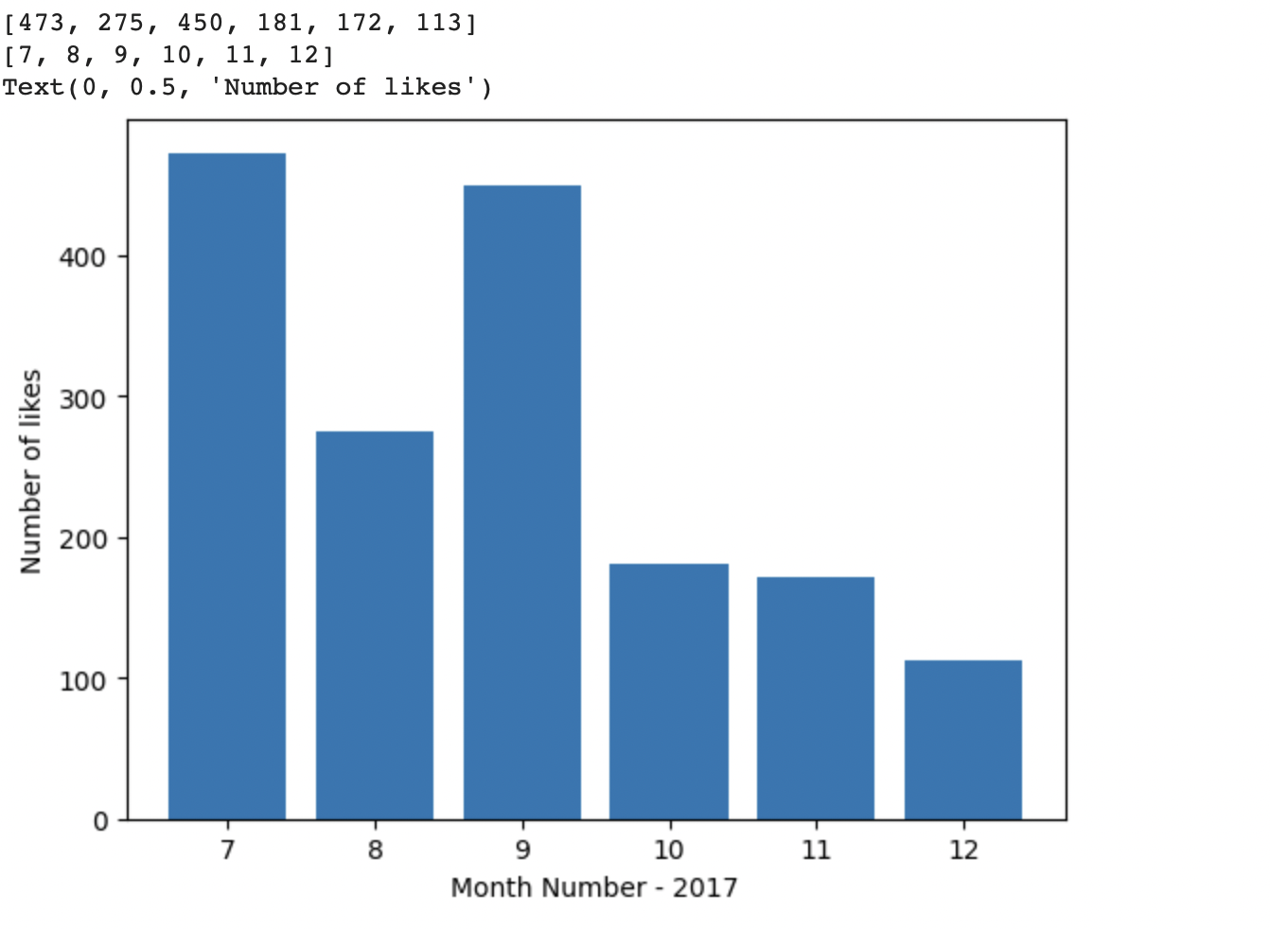

Figure 11

Number of likes in 2018:

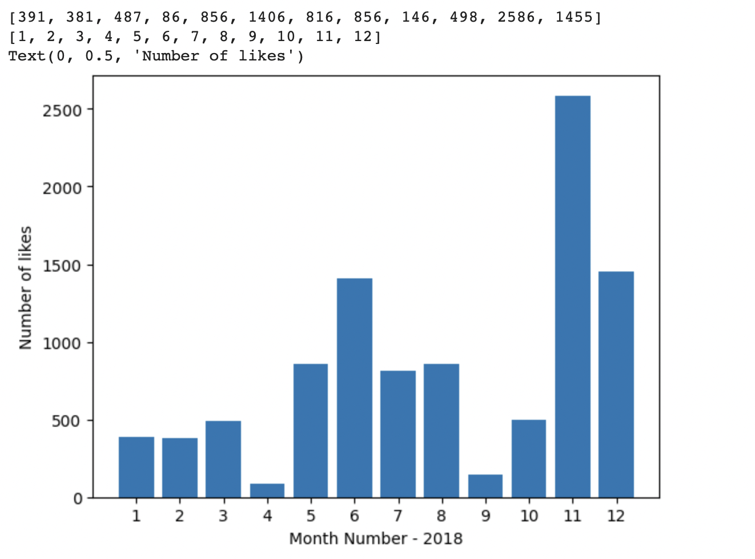

Figure 12

Number of likes in 2019:

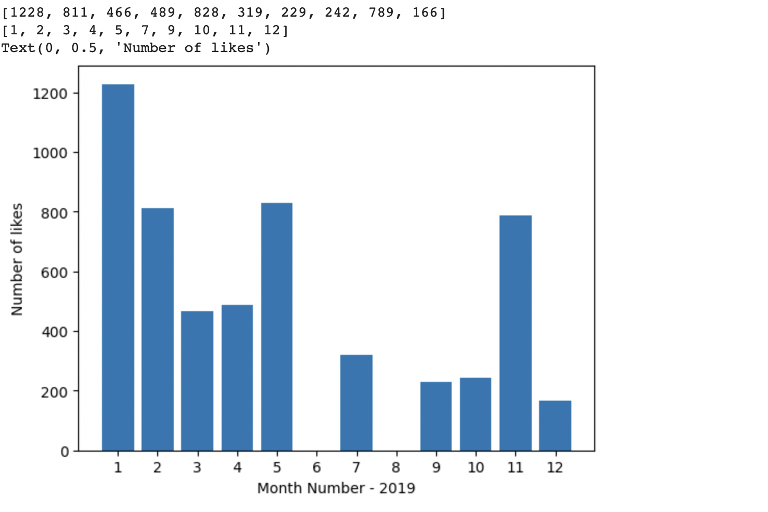

Figure 13

Number of likes in 2020:

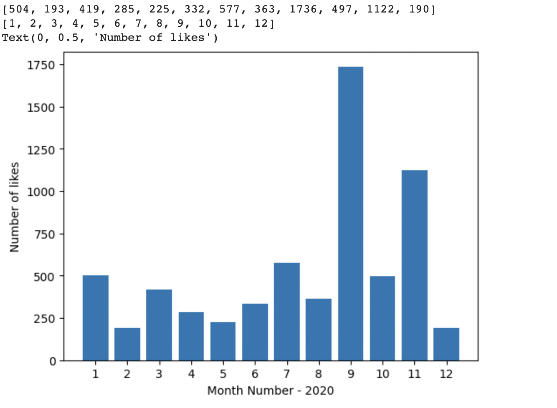

Figure 14

Number of likes in 2021:

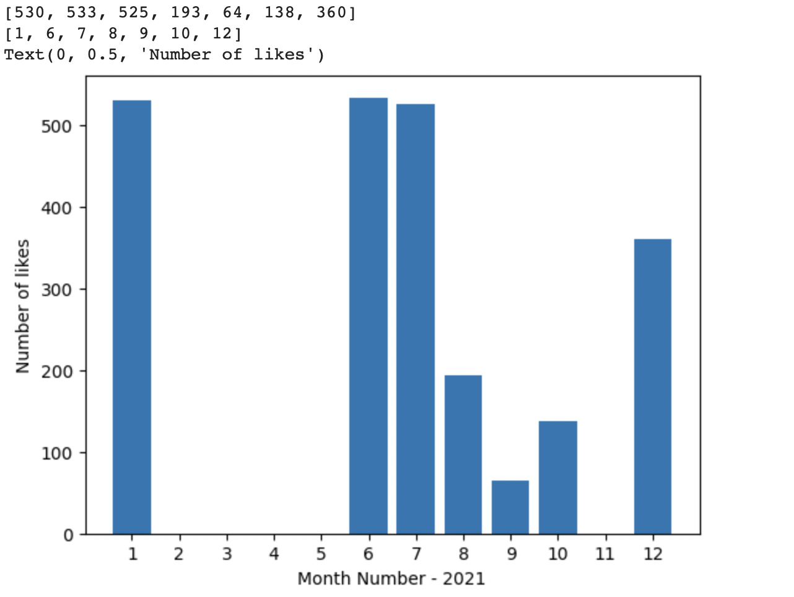

Figure 15

Number of likes in 2022:

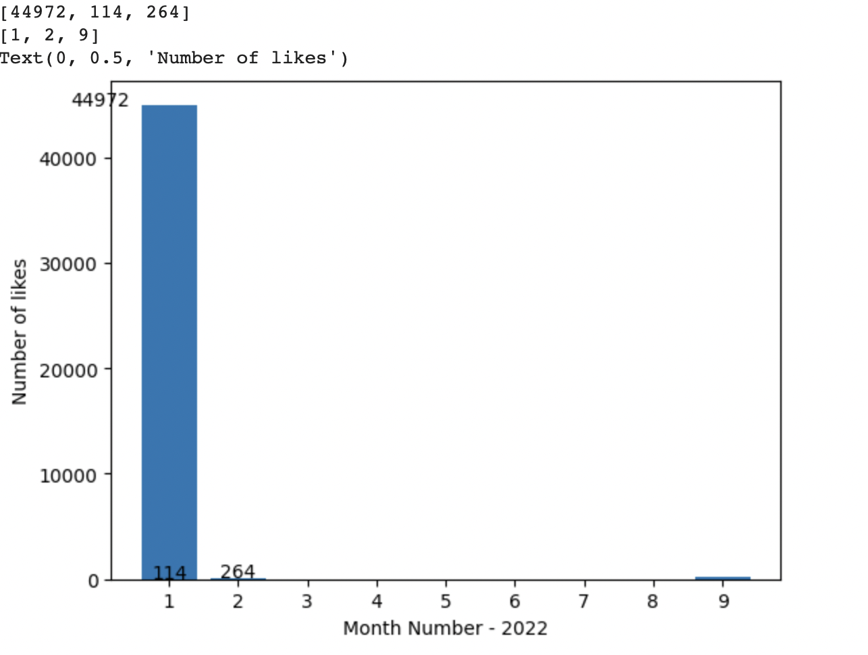

Figure 16

Analyzing the fluctuation in likes per post across different months of each year yields valuable insights into the audience engagement patterns of the business over time.

Upon examining the trends in likes garnered on posts throughout 2022, a notable observation emerges: one particular post received a significantly high number of likes in January. This anomaly could be attributed to various factors such as the content's quality, relevance to the audience, or strategic timing of the post.

Furthermore, there is an increase in the frequency of posting photos during the latter half of all the years . This surge in posting activity aligns with a corresponding rise in the number of likes received on posts during these months.

Interestingly, the data collected on invoices mirrors the posting frequency observed during these months, suggesting a potential correlation between posting frequency and engagement levels.

1. The total number of likes received over six years shows how active the social media account has been. In total, there were **71,331 likes.** On average, that's about **11,888 likes** per year.

Looking at these numbers, it seems like the account has a good amount of followers. It's likely that the number of likes will keep going up over time. As the account becomes more popular, more people will see the posts and like them.

So, it's a positive sign that the account is doing well and that people are interested in what it shares. The total number of likes received over six years, coupled with the average likes per year, provides a comprehensive overview of the account's activity and engagement levels. It highlights its ongoing relevance and appeal to its audience, serving as a testament to its effectiveness in capturing and maintaining audience interest over time.

**Analyzing the correlation of the rate of conversion to invoices and the social media presence**

1. Yearly Conversion Rate

| Year | Conversion Rate (%) |
| --- | --- |
| 2019 | 8.37 |
| 2020 | 23.75 |
| 2021 | 24.50 |
| 2022 | 20.69 |
| 2023 | 37.72 |

TABLE 1

1. Yearly Total Likes

| Year | Total Likes |
| --- | --- |
| 2017 | 1664 |
| 2018 | 9964 |
| 2019 | 5567 |
| 2020 | 6443 |
| 2021 | 2343 |
| 2022 | 45350 |

TABLE 2

Summary of the tables:

1. The percentage rate of conversion of estimates to invoices varied across the years, with the highest rate observed in 2023 (37.72%) and the lowest in 2019 (8.37%).

2. The total likes per year also varied, with the highest number of likes recorded in 2022 (45350) and the lowest in 2021 (2343).

3. The correlation coefficient between the conversion rate and the total likes per year is 0.0902, indicating a very small correlation between the two variables. This suggests that the rate of conversion of estimates to invoices has a limited influence on the number of likes received in a year.

The high correlation coefficient of **0.993** between the amounts provided by estimates and invoices per year indicates a strong positive linear relationship between these two variables. In other words, there is a close correspondence between the amounts estimated and the actual amounts billed through invoices each year.

Data analysis can be seen on Google Colab:

<https://colab.research.google.com/drive/1Z8RYZpM3T7rmB-HU-h7hYNG49FPYDJaf?usp=sharing>

<https://colab.research.google.com/drive/1DuH7_UjYjBu60Kmast6whnb_7JmfEIoi?authuser=2#scrollTo=zuz5NyqlWmRM>

### **INTERPRETATION OF RESULTS AND RECOMMENDATION**

**INTERPRETATION**

Conversion Rate Trends:

The analysis of conversion rates from estimates to invoices reveals fluctuating trends over the years. While there are variations in the conversion rates from year to year, a general trend of improvement can be observed, with higher rates recorded in more recent years. This indicates potential enhancements in sales strategies or customer engagement efforts.

Total Likes Patterns:

The total likes received per year also exhibit variability, with notable peaks and troughs across the six-year period. The highest total likes were recorded in 2022, suggesting a significant increase in audience engagement or the effectiveness of content strategies during that year.

Correlation Analysis:

The correlation coefficient between conversion rates and total likes per year is found to be very small (0.0902), indicating a weak correlation between these two variables. This suggests that while there may be some influence of conversion rates on audience engagement, other factors likely play a more significant role in determining the number of likes received per year.

**RECOMMENDATIONS**

The business needs to increase the rate of conversion of estimates and invoices. They have to increase business reach during the months of April, May, June, July.

2020 and 2021 were years when the profit was maximum.

The business can utilize a combination of online and offline marketing channels, including social media, email marketing, local advertising, and networking events, to increase visibility and attract potential clients.

From the data collected from instagram, we can see that the number of invoices do not affect the number of likes on the post. It is evident that the number of posts and social media reach should be increased to get a larger amount of likes.

Invoices might affect the number of likes if photographs taken in every photo session are put on the social media account. Audience reach will increase if posts are put up regularly and social media management is done.

Correlation between estimates and invoices is high which shows us that the number of invoices depend on the number of estimates.

For increasing business, these points should be taken into consideration:

1. Increase Social Media Presence:

Develop a social media strategy focused on creating engaging content and increasing brand visibility.

Regularly post high-quality photos and videos showcasing your work, behind-the-scenes footage, client testimonials, etc.

Engage with your audience by responding to comments, messages, and participating in relevant conversations.

Explore different social media platforms and identify the ones where your target audience is most active.

1. Properly Storing Estimate and Invoice Records:

Implement a robust system for storing and organizing estimate and invoice records.

Use digital tools or software to streamline the process and ensure easy access to historical data for analysis.

Regularly analyze this data to identify trends, patterns, and opportunities for business improvement.

1. Target Seasonal Photoshoots:

Develop marketing campaigns targeting seasonal events like weddings, holidays, graduations, etc.

Offer special packages or discounts for seasonal photoshoots to attract more clients.

Collaborate with wedding planners, event organizers, and other professionals to expand your reach during peak seasons.

1. Invest in Quality Equipment:

Allocate resources to invest in high-quality photography equipment and gear.

Upgrading your equipment can help improve the quality of your work and enhance client satisfaction.

Consider renting equipment for specific projects or investing in used equipment to minimize costs.

1. Off-Season Photoshoots:

Use the off-season periods to experiment with new styles, techniques, and locations.

Organize themed photoshoots or collaborate with local businesses for creative projects.

Share the results on social media to keep your audience engaged and maintain visibility during slow periods.

1. Website Development:

Create a professional website to showcase portfolio, client testimonials, pricing packages, and contact information.

Regularly update the website with fresh content and blog posts to demonstrate your expertise and attract potential clients.

We saw that ERP softwares are not compatible for small businesses. These are the points which were highlighted:

1. There is no system accessible for small enterprises to maintain their data, such as customer, product, quotations, invoices, etc., for free or at a minimal cost.
2. It's likely that efficient apps don't have mobile versions.
3. It is challenging to consistently and accurately retain data.
4. Unable to provide the business with data-driven insights.
5. Manual maintenance is time-consuming and laborious.

Solutions for a better ERP Tool:

1. Make ERP mobile apps more interoperable.
2. Provide better analysis methods
3. Automatic maintenance of data.
4. The software should be cheap/free and should be able to store data of many years.

Authentication documents:

<https://drive.google.com/drive/folders/1Q1G3qr0DPIc2Iic5qlfZ4oQY8HXbcQii?usp=sharing>

Links to data and colab files:

<https://colab.research.google.com/drive/1Z8RYZpM3T7rmB-HU-h7hYNG49FPYDJaf?usp=sharing>

<https://colab.research.google.com/drive/1DuH7_UjYjBu60Kmast6whnb_7JmfEIoi?authuser=2#scrollTo=zuz5NyqlWmRM>

<https://drive.google.com/drive/folders/1GV8H4u6WhgjTleW6Bgz_DiQ9b8puCINQ?usp=sharing>

— End of the Report —